**Rain1.9 Installation Manual**

To install the Game, please follow the following instructions.

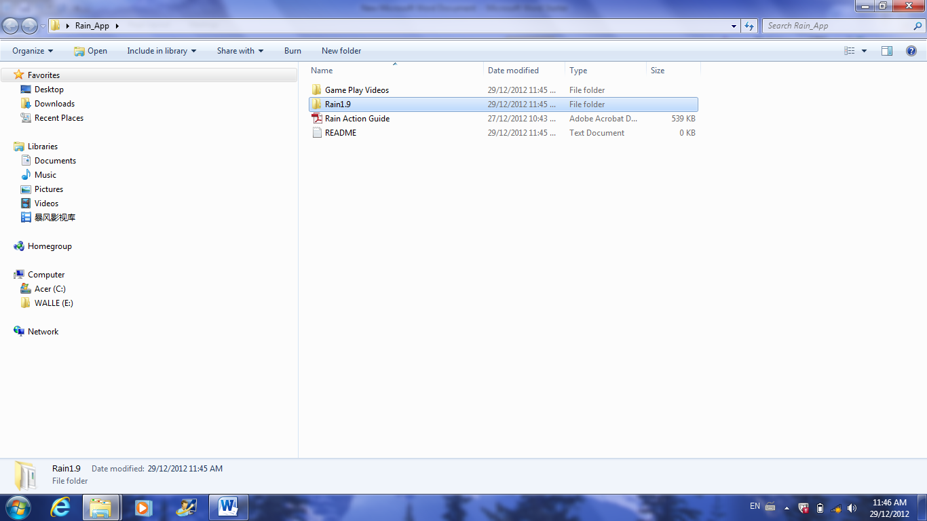

Open the disc drive by double clicking the disc icon in **My Computer**.

As shown above, there should be four separate files available.

Double click on the folder titled **Rain1.9**.

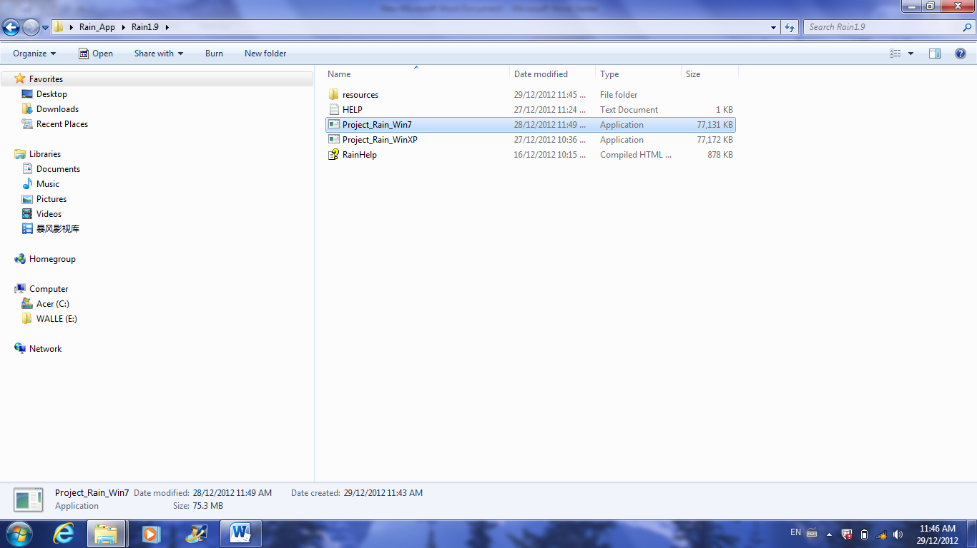

After opening the **Rain1.9** folder, this screen should appear.

Double click on the icon titled **Project_Rain_Win7** or **Project_Rain_WinXP**, based on your operating system.

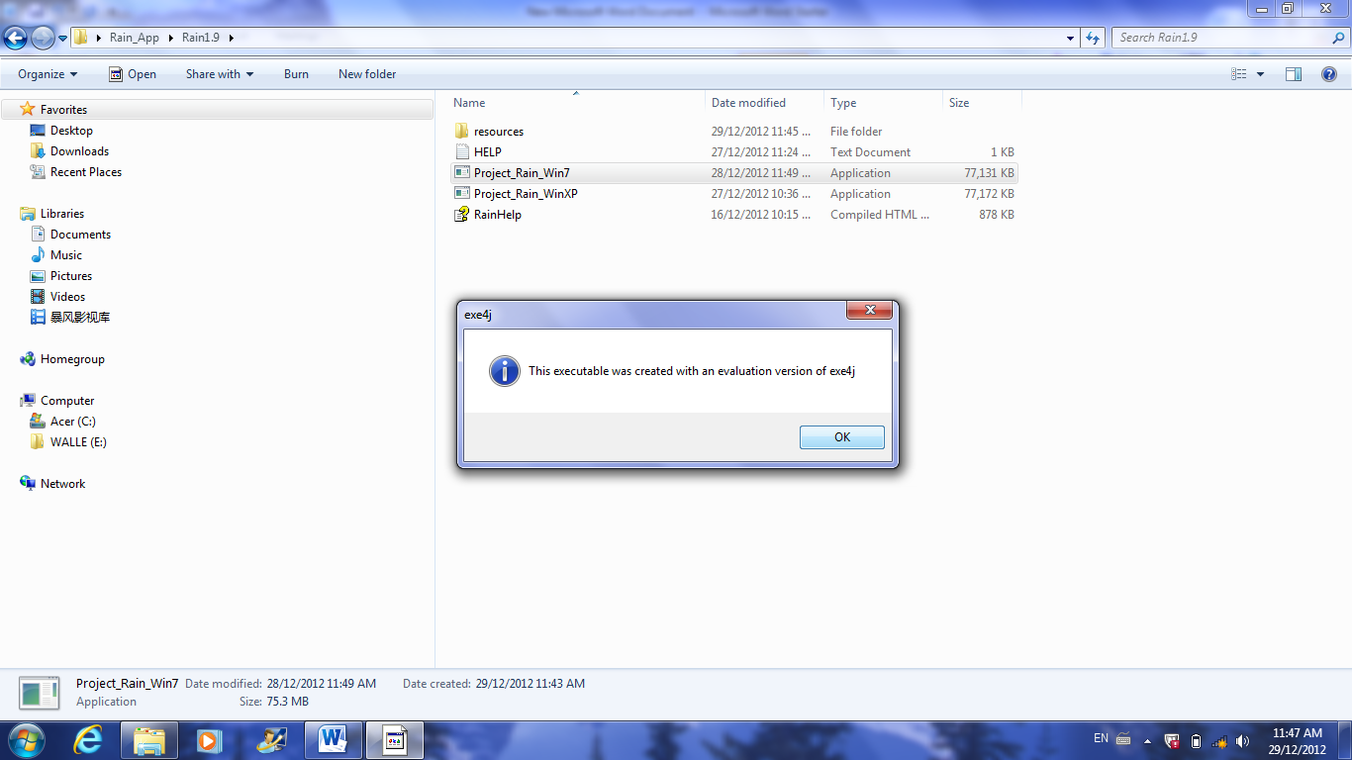

The exe4j window should open.   
Press **OK** to continue.

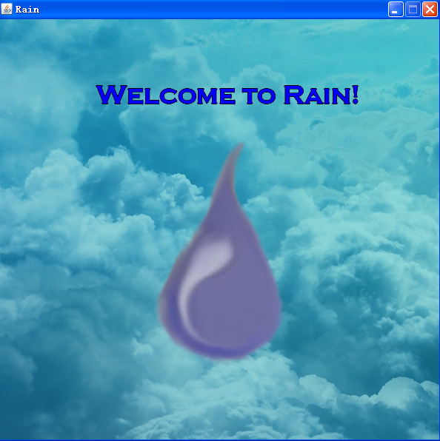

*Congradulations on successfully opening Rain.*Visit <https://www.youtube.com/user/RainEnvironmental> for updates.